MORSE CODE
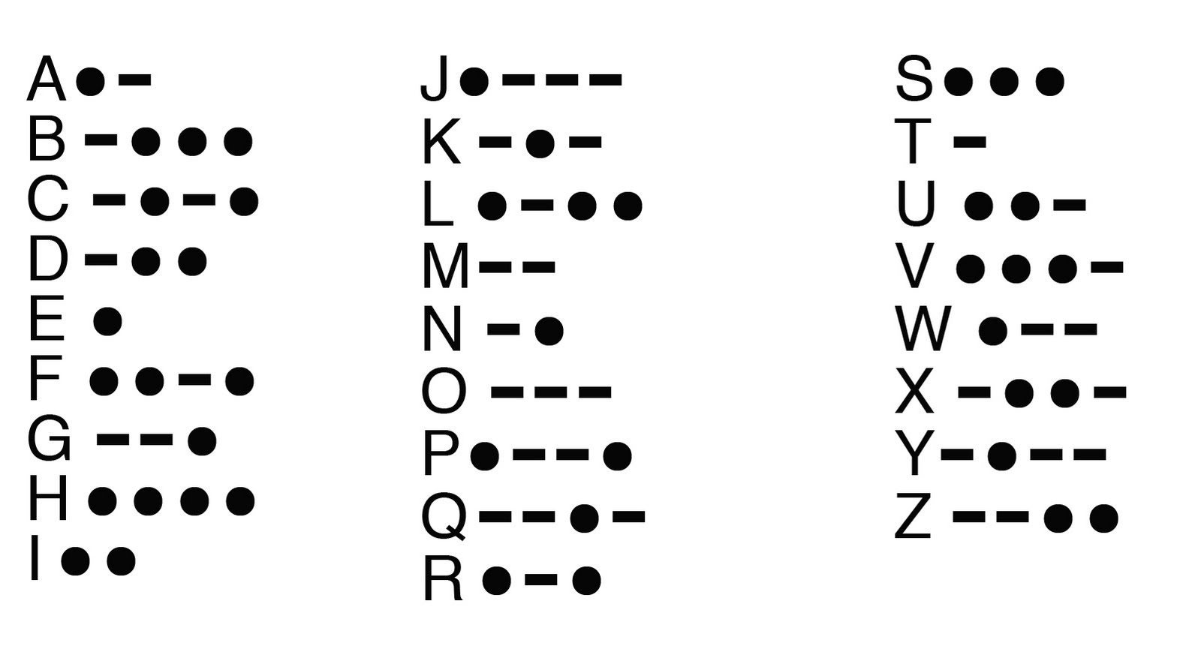

MORSE CODE

